**Classroom Activity:** **Write a program to develop a bank account management system. The details of the bank account should be keep private**

**Code:**

|  |
| --- |
| class BankAccount {  #accountNumber;  #accountHolderName;  #balance;    constructor(accountNumber, accountHolderName, initialBalance) {  this.#accountNumber = accountNumber;  this.#accountHolderName = accountHolderName;  this.#balance = initialBalance;  }    getDetails() {  return `Account Holder: ${this.#accountHolderName}, Account Number: ${this.#accountNumber}`;  }    deposit(amount) {  if (amount > 0) {  this.#balance += amount;  return `Deposit successful. New balance: $${this.#balance.toFixed(2)}`;  } else {  return 'Deposit amount must be positive.';  }  }    withdraw(amount) {  if (amount > 0) {  if (amount <= this.#balance) {  this.#balance -= amount;  return `Withdrawal successful. New balance: $${this.#balance.toFixed(2)}`;  } else {  return 'Insufficient funds.';  }  } else {  return 'Withdrawal amount must be positive.';  }  }    getBalance() {  return `Current balance: $${this.#balance.toFixed(2)}`;  }  }    // Bank Account Management System  class Bank {  constructor() {  this.accounts = [];  }    addAccount(account) {  this.accounts.push(account);  }    listAccounts() {  return this.accounts.map(account => account.getDetails()).join('\n');  }    findAccount(accountNumber) {  return this.accounts.find(account => account.#accountNumber === accountNumber);  }  }    // Create a new bank  const bank = new Bank();    // Add accounts to the bank  const account1 = new BankAccount('123456789', 'Alice Johnson', 1000);  const account2 = new BankAccount('987654321', 'Bob Smith', 500);    bank.addAccount(account1);  bank.addAccount(account2);    // List all accounts in the bank  console.log('Bank accounts:');  console.log(bank.listAccounts());    // Deposit money into an account  console.log(`\nDepositing into Alice's account:`);  console.log(account1.deposit(200));    // Withdraw money from an account  console.log(`\nWithdrawing from Bob's account:`);  console.log(account2.withdraw(300));    // Check account balances  console.log(`\nAccount balances:`);  console.log(account1.getBalance());  console.log(account2.getBalance()); |

**Output:**

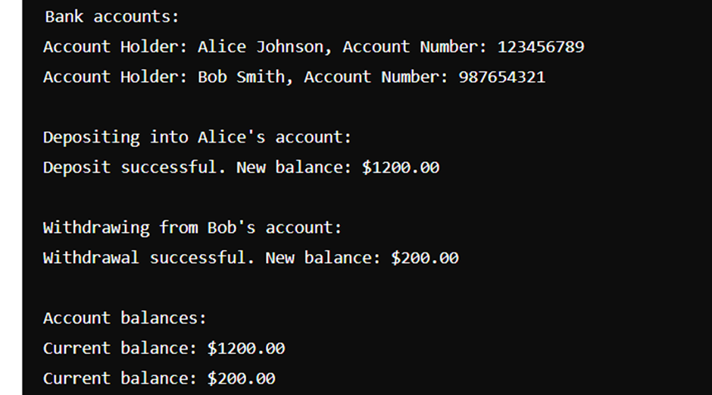

**Execution-Steps:**

* Create a JavaScript file with any name
* Write the code
* Run the code in the terminal using F5 or right click and go to inspect and you can get the output in the console as well.